Responses to Pip

I appreciate the efforts that Shawn has taken to put together the list below and to put me on a PiP and someone who doesn’t meet the minimum company requirements based on the items below , that he may not have all the details about.

As people managers we fall short in some areas and we as leaders we aught to take criticism as a positive way to grow our selves. When I mentioned on the call we had with HR and Shawn on the 20th Feb 2023 that he aught to have told me and brought these issues to me in the 1:1 that used to have till late Dec since we had no 1:1 in Jan 2023 till when I got a PiP. He said that I am challenging his leadership on the call with HR which I think is not right , because everyone has to take that as something to reflect on and see how things can be made better. Companies do take bad reviews or challenges to better their products.

* As a Phoenician I think he has not had my back , if what he says that from sept last year there have been complaints why haven’t these shown up on the 1:1
* Okay let say that those issues started way back in sept last year as he started on the call , why didn’t he talk about those issues with me even during the Get together party that had in Amelia Island, As a leader I had a session with Kiran my report at Amelia and we talked about Work related Issues as well as ways of how we could make our API and Microservices work be know to the VA and AFS by us starting to do Demos- Which Mary our scrum master run with and we started demoing API automation to the Team.
* I have comeout bold to make it happen that we don’t put in the backlog of any items that are meant to be automated as we wouldn’t have enough coverage for all the functionalities that have been developed in the PIs case in point when
  + SRI suggested that we put all items that we were supposed to automate for PI12 in the backlog and we do automation for PI13 items , we had a call including AFS and VA and it was agreed that all automation had to be done, we took it to ourselves Me and Kiran to spend extra time to knock out these items which we were able to accomplish PI13 we have worked on more API Automation Tasks than what we should have done and we still have that drive to complete PI13 without any item going to the Backlog or even spilling into the PI sprint. – I don’t see any non performance here.
* I have always produced and submitted the LGY Automated Test Report on time to SRI to approve and then I send it out to Alison , Chase Heather , Abdelkader Aisha Copying SRI and Shawn

Response to the examples stated Below

Examples of Performance Failing to Meet the Company’s Minimum Expectations

In January, during a conversation with Mitch Gottlieb of the VA, Ivan spoke on his frustrations with

Srikanth’s management. The term “micromanaging” was used when Mitch notified Srikanth. While

working with the client, you must never present communication that challenges our one team

approach. You must always present as one team between Phoenix and AFS to our client, the VA.

Ivan has been unresponsive in his communication via teams. – As I said on the call my intention was not to tell him my issues but was to ask for ways to be better at what I do

On February 10, 2023, at 9:36am eastern, Shawn saw Srikanth tag Ivan in a DSU chat. Shawn

sent a chat to Ivan to ask about it. It was never responded to.

Response

On that day I chatted back and forth with Sri and below are the screen shoots

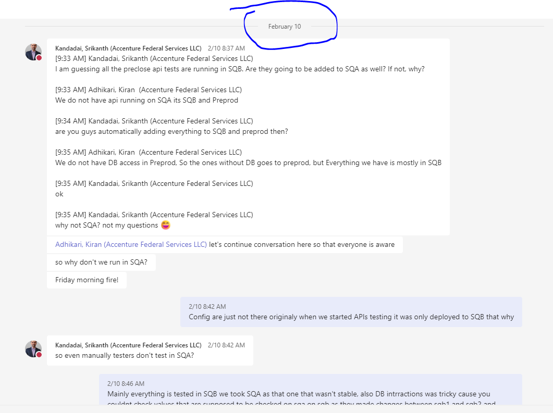

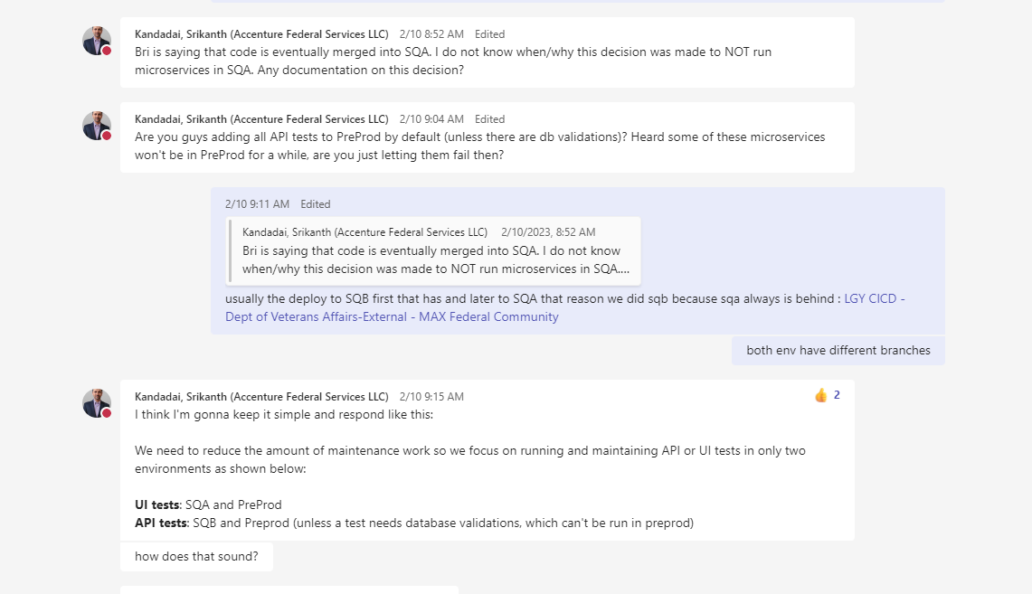

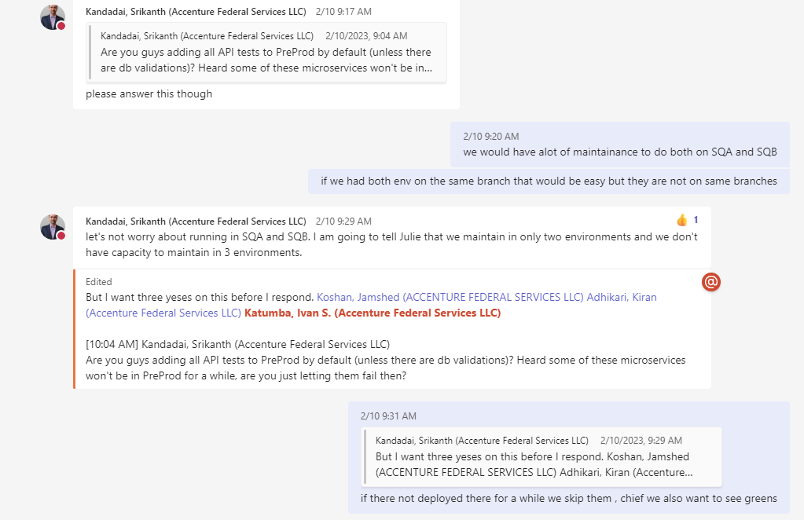

. On February 16, 2023, at 10:42am eastern, Srikanth asked Ivan to handle some UI tests via a

chat. AS of February 17, 2023, at 10:11am eastern, he has not responded.

Response

On 15th I had private chats with Sri as below and also that night worked late till 11Pm

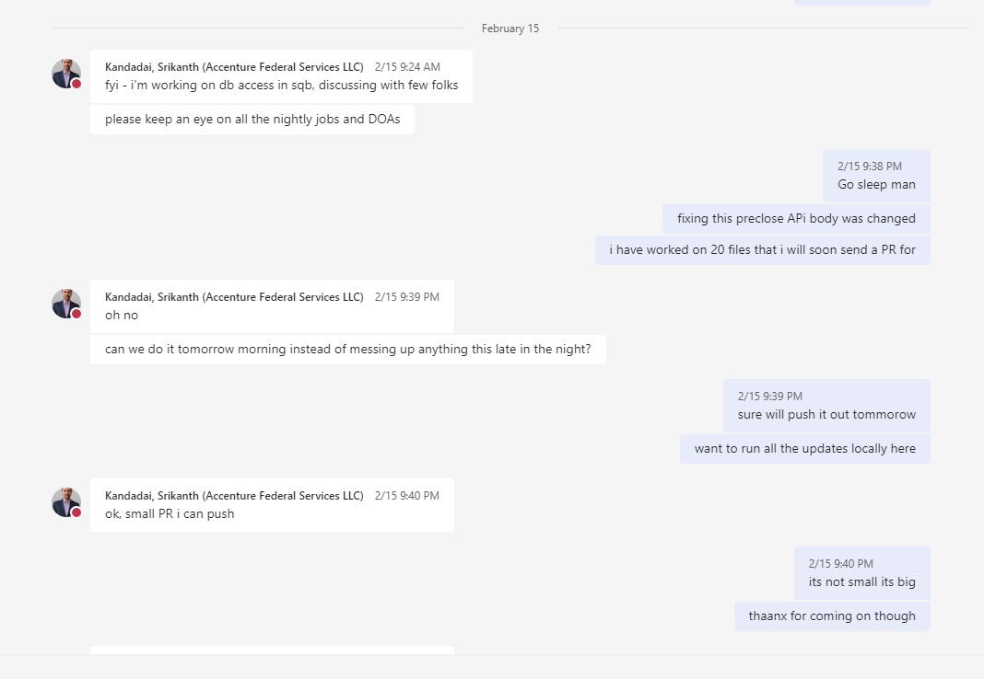

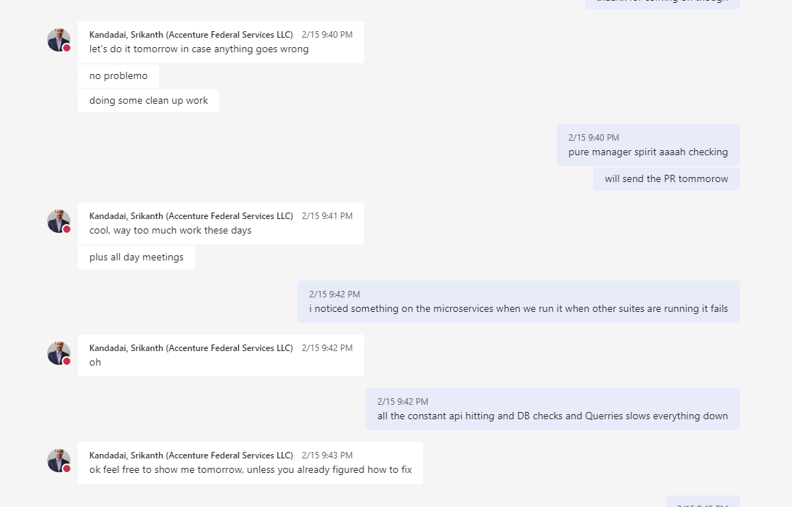

On the Feb 16th

I pushed out the fixes to the API calls that were failing and this consisted of 20 Files that touched about more than 42 Tests for APIs that were failing and that would fix most items on the maintaince list

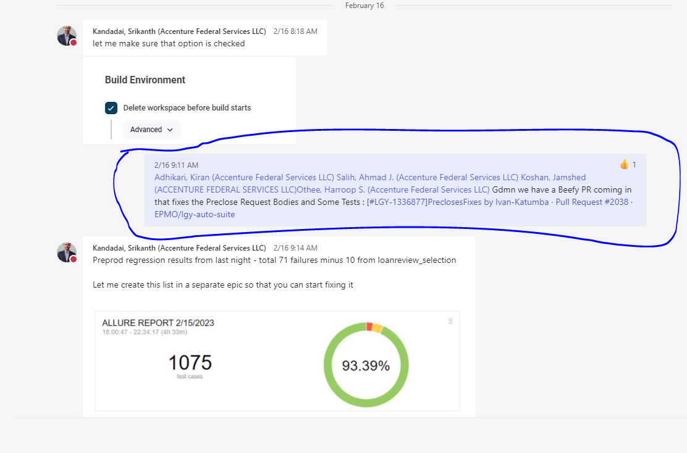

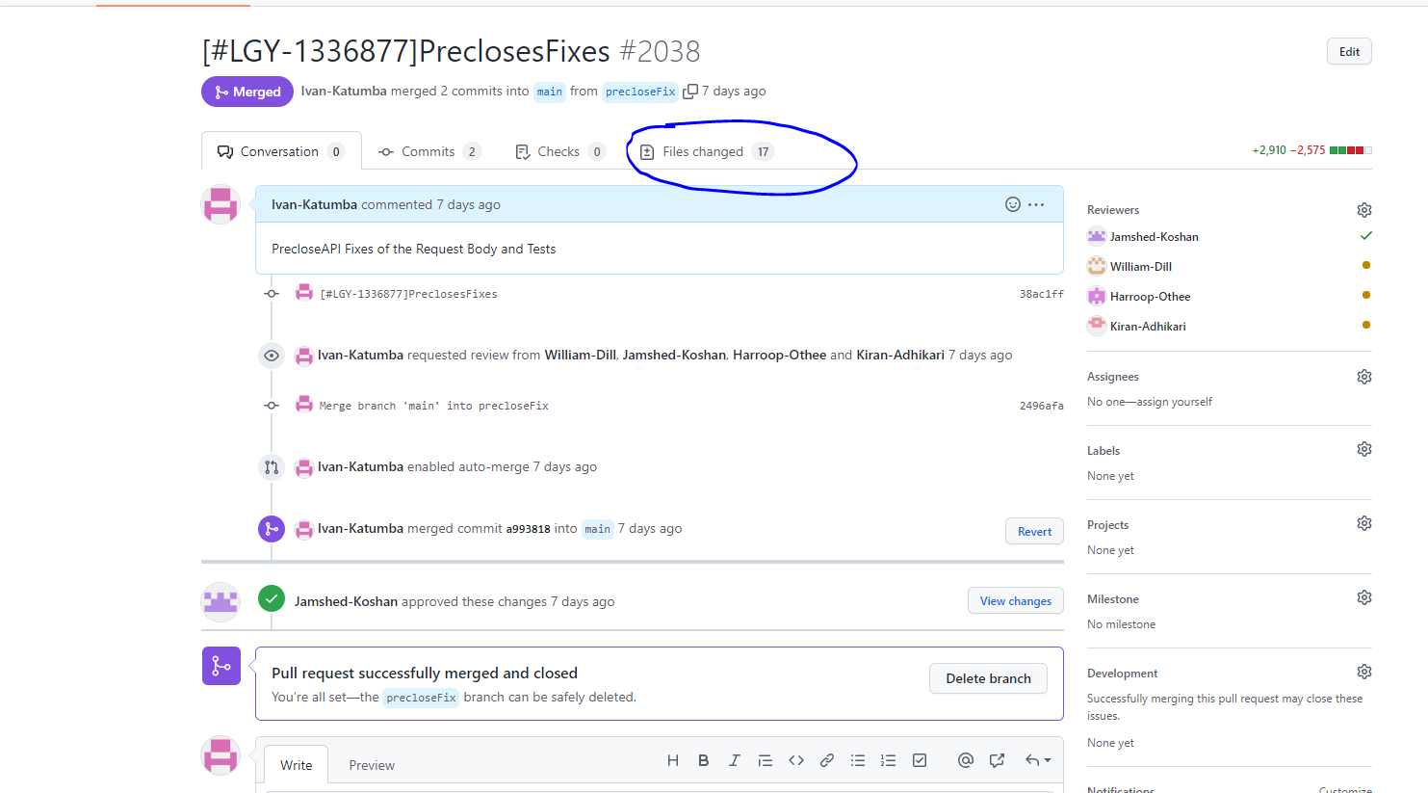

Ivan’s performance is not meeting his leaders’ expectations.

. During late January and early February of 2023, the VA project did a “down fresh”. This

activity causes the automation team to have to fix tests broken by this activity. Ivan did not

participate in taking any of the maintenance fixes. Not for the UI portion of tests. Not for

the API/microservices tests that he owns. 0 of 67 sub-tasks were owned by Ivan.

As part of the Hall Monitor I generated maintaince list and assigned task to the different members in the team as seen by the link of the task below : Not all the 67 Items were to be fixed by Me.

[[LGY-1347088] AUTOMATION: Repair 02/13/2023 SQA and SQB Microservice broken and failed - VA USDS Jira (max.gov)](https://vajira.max.gov/browse/LGY-1347088)

Most of the current failures that haven’t been resolved are as a result of Issues we have had with Preclose API- This Kiran can attest to this

Below is the work that was logged and pushed to fix some of the failures

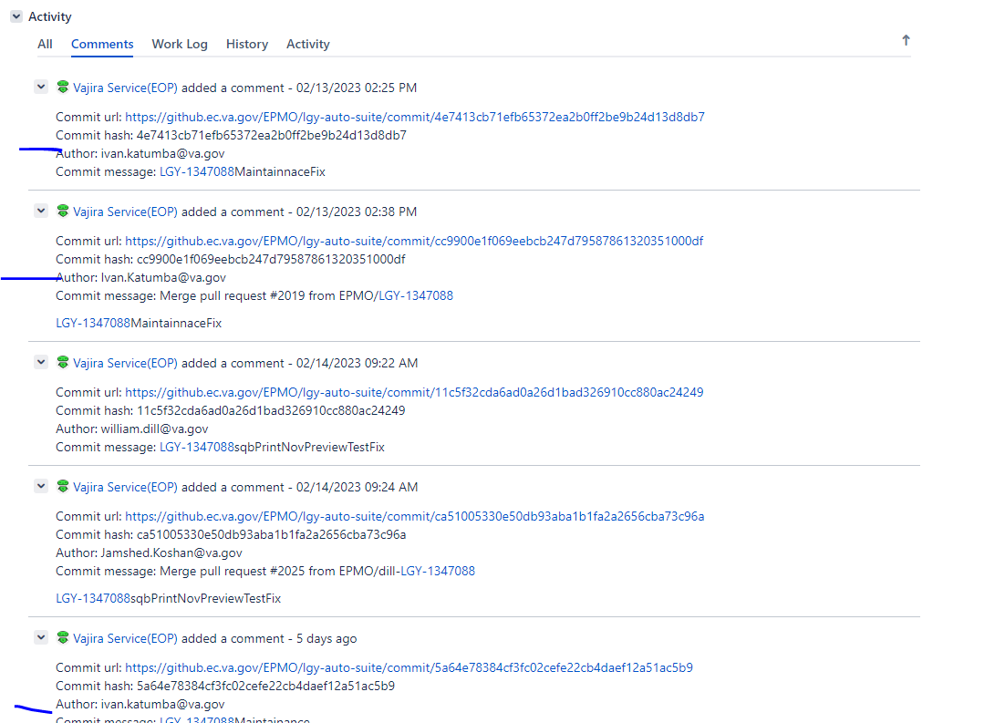

. On February 2, 2023 at 5:38pm Srikanth shared a maintenance task that had not been

completed. For test weblgy: As a LENDER_ADMIN with no access to FFL Info what I access

[url] denial message of: GROVER ADAMSJTAWET is not authorized. The test was not fixed by

Ivan. The test had ben failing since January 8th. The test was also not done on PreProd.

Ultimately this miss led to an escaped defect condition.

I was Sick Leave from the 31st Jan 2023 till the 3rd Feb 2023 could not have fixed this test while on sick leave.

Even when I returned after a whole week off I managed to fix and close the Tasks on the Maintenance list:

[[LGY-1346511] AUTOMATION: Repair 01/29/2023 SQA and SQB Microservice broken and failed - VA USDS Jira (max.gov)](https://vajira.max.gov/browse/LGY-1346511)

. On February 16, 2023, at 9:51am, a team member pointed out that the microservices build

which Ivan owns, hasn’t been run in several days. As he is the primary lead on “hall

monitoring” this is something he should have already caught and addressed.

A Code PR that would address most failures was pushed and approved as seen below



About the API suite not running see the Below

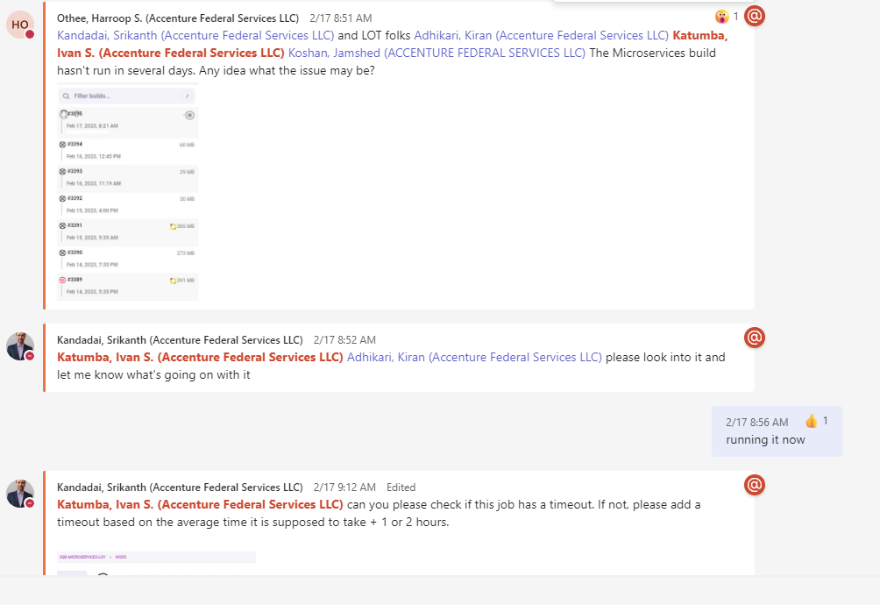

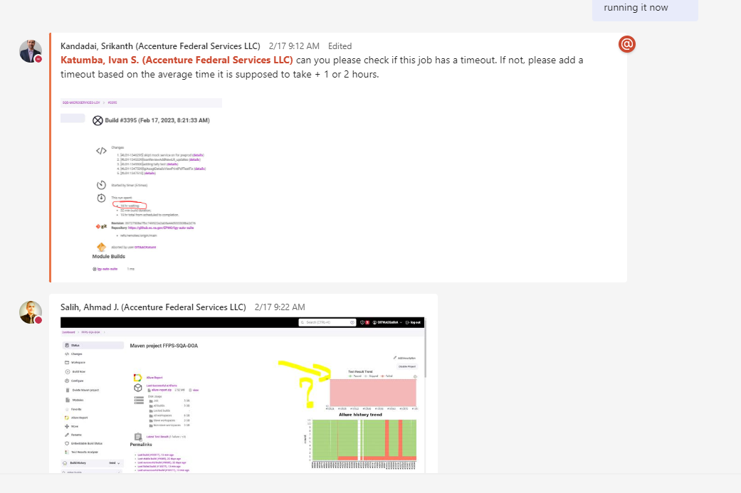

I responded to that below and we chatted about it on the DSU call which Shawn wasn’t part of

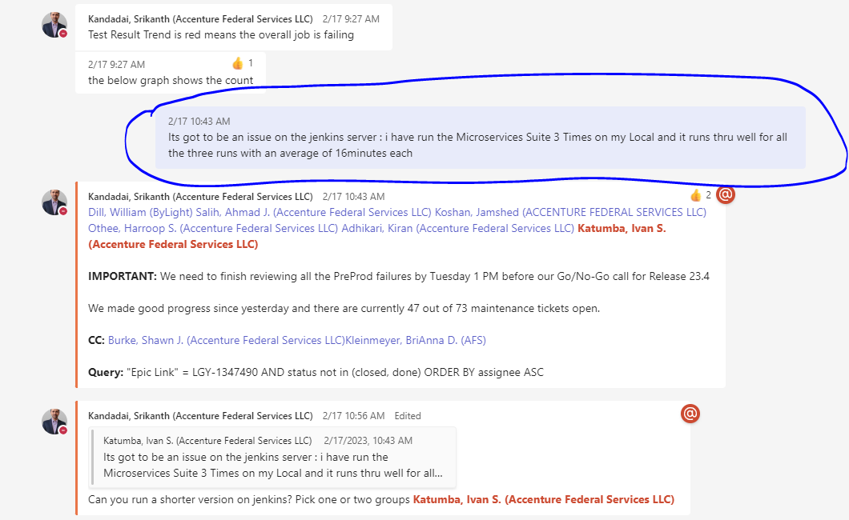

As suggested by SRI to run the subset of the API Job on the Jenkins server to ascertain what the Problem was I rerun a subset and attached the report to the DSU chat as seen below

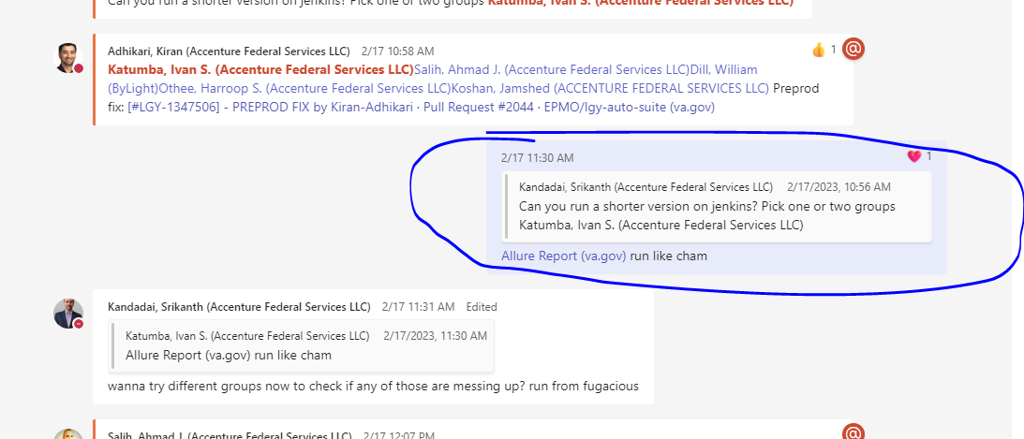

Link to the Report that I attached to DSU was : [Allure Report (va.gov)](https://automation-jenkins.lgy.va.gov/view/_Fugacious/job/FUGACIOUS-RUNNER%20(SQB)/1/allure/)

On the 17th Feb still on the DSU chat we continued to chat about the same issue of the Job not running in Jenkins as seen below

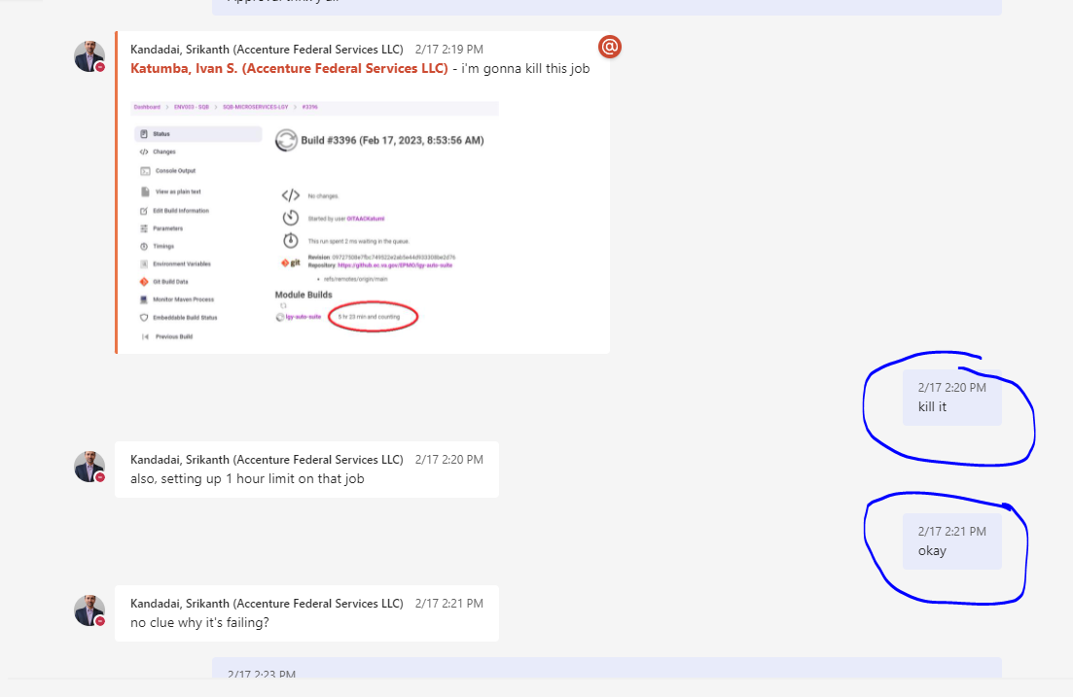

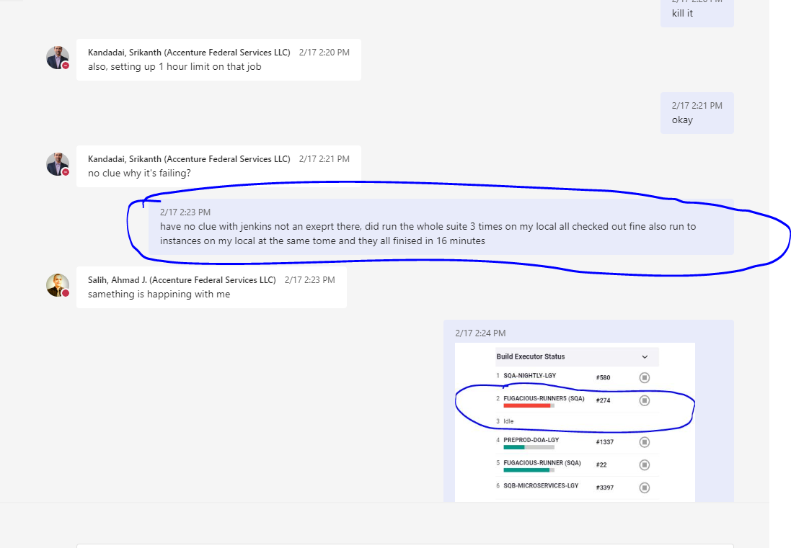

Another Team member also expressed the same concern for his JOB

Response to the section of Expectations that have been shared btn Phoenix and AFS

These expectations are shared between your Phoenix and AFS leadership:

1. There is a list of components that are assigned to all the automation testers. Ivan needs to

take ownership of UI maintenance tasks going forward.

All the microservices and API calls are a total of 394 Tests and every week we have atleast 20+ Tests are always broken because of Data and Env issues , ontop of my Teams work ticket that I have to test, and Automate for the sprint. We have a total 7 Automation Engineers and 2 including my self are responsible to API – I have asked to leave me maintain the API suite since the other 4 engineers have mainly focused on UI Tests. – Me doing both is a heavy load on my shoulder.

2. One aspect of Ivan’s role is to work on the assigned tasks from the maintenance list. He

needs to make necessary fixes, provide comments, and promptly resolve the tasks in Jira

every week.

I have fixed tasks on theses past 2 maintenance lists as shown below

* [[LGY-1346511] AUTOMATION: Repair 01/29/2023 SQA and SQB Microservice broken and failed - VA USDS Jira (max.gov)](https://vajira.max.gov/browse/LGY-1346511)
* [[LGY-1347088] AUTOMATION: Repair 02/13/2023 SQA and SQB Microservice broken and failed - VA USDS Jira (max.gov)](https://vajira.max.gov/browse/LGY-1347088)

3. You must show more responsibility when he is the “hall monitor” for a given Sprint. This

applies to hall monitoring, which happens approximately once in 3 months or so, or towards

similar “big effort”; an example being the down fresh.

4. When leading the maintenance, you need to be active with the team, assigning items out,

and ensuring they are getting done, in addition to completing your own. The DSU should be

your main forum for this work. –

* Items have been assigned and everyone gives status on DSU on how far and as and when they will fix then – example is the latest : [[LGY-1347088] AUTOMATION: Repair 02/13/2023 SQA and SQB Microservice broken and failed - VA USDS Jira (max.gov)](https://vajira.max.gov/browse/LGY-1347088)

5. He must understand the importance of requests by his leaders (AFS, Phoenix, or otherwise),

acknowledge, and provide a prompt response. - Noted

6. He should bring concerns about the team to his project leader (currently Srikanth). These

concerns can then be addressed as healthy conversations. If you need an escalation point,

Shawn will be that escalation point. If Shawn is unavailable, or cannot address your

concerns to meet your needs, your next escalation point is Melanie Lewis.-- Noted

7. Time working must be tracked in Jira. This includes iteration work as well as maintenance

items. As shown on the PR screens above all the Items I work on if there is any code change I tag it to the Ticket

8. If your leader asks you to do something, such as training, that is a requirement of your job. If

you feel the ask is unreasonable, you still need to accept it, and then escalate to Shawn or

Melanie to resolve. – Not at anyone time have I failed to train anyone on the team including doing it after work hours (Please feel free to inquire from any Automation Team Member)

9. We will be moving your current reports to another leader to allow focus on this critical

deliverable. - Noted

10. We must exhibit caution when working with the client and talking about members of our AFS

+ Phoenix one team. Despite any “good natured Ness” of the client, long term relationships,

previous reporting structures, or any other actions that make us feel comfortable with them,

we never discussion challenges to our AFS + Phoenix team with them. Those are always

escalated to me. If I am unavailable, or cannot address your concerns to meet your needs,

your next escalation point is Melanie Lewis. -- Noted

11. We will meet with Srikanth to review this again. Ivan and Shawn will meet weekly to discuss

progress. Multiple check-ins with Srikanth will also be setup.